Status Screen Information Display – S550 SVT Only - CGEA1.3

Functional Description

The purpose of the SVT Status screen display is to provide the status of some of the performance related settings chosen by the driver.
The SVT Dashboard Screen consists of the following feature statuses:
- Drive Mode
- Steering Feel
- Launch Control
- Advancetrac
- Adjustable Dampers
- Dual Exhausts

The SVT status screen is part of the Track Apps settings menu, which shall be accessed via the 5-way Message center display switch.

The SVT Status Screen warning correlate the 5-way switch and the Operational_Mode to determine when to display the Status screen information.

Interfaces

Interface Context Diagram (I/O Block Diagram)
Figure 1 Warning – SVT Status Screen Diagram

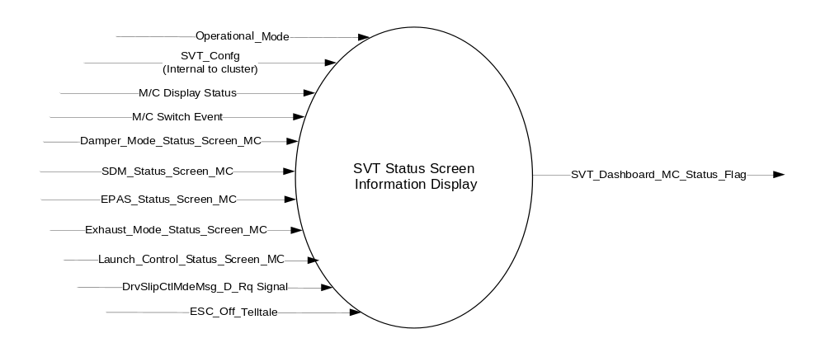

Inputs
      - INTERNAL:
    - Operational_Mode
    - SVT_Confg – Config bit that differentiates the SVT cluster from other cluster variants.
    - SDM_Status_Screen_MC – Refer to the Selectable Drive Modes Control Function – S550 SVT Specific – CGEA1.3 STSS for more information
    - Damper_Mode_Status_Screen_MC – Refer to the “Dampers Settings Function – S550 SVT Only – CGEA1.3” STSS for more information.
    - EPAS_Status_Screen_MC – Refer to the “EPAS Selectable Steering Effort Control Function – S550 Specific – CGEA1.3” STSS for more information.
    - Exhaust_Mode_Status_Screen_MC – Refer to the “Dual Mode Exhaust Control Function – CGEA1.3” STSS for more information.
    - Launch_Control_Status_Screen_MC – Refer to the “Launch Control Performance Function – S550 Specific - CGEA1.3” STSS for more information.
    - M/C Switch Event – OK Button Press
    - ESC_Off_Telltale – Refer to the “ESC Off Tellate – CGEA1.3” STSS for more information.

      - MUX message on the CAN Bus

- DrvSlipCtlMdeMsg_D_Rq Signal
Signal Name | Size  (bits) | Detail | Units | Res. | Offset | State Encoded | Min. | Max.
DrvSlipCtlMdeMsg_D_Rq | 2 |  | SED | 1 | 0 |  | 0  (0x0) | 31 (0x1F)
DrvSlipCtlMdeMsg_D_Rq |  | No Message |  |  |  | 0x0
DrvSlipCtlMdeMsg_D_Rq |  | Message_1 |  |  |  | 0x1
DrvSlipCtlMdeMsg_D_Rq |  | Message_2 |  |  |  | 0x2
DrvSlipCtlMdeMsg_D_Rq |  | Message_3 |  |  |  | 0x3
DrvSlipCtlMdeMsg_D_Rq |  | Message_4 |  |  |  | 0x4
DrvSlipCtlMdeMsg_D_Rq |  | Message_5 |  |  |  | 0x5
DrvSlipCtlMdeMsg_D_Rq |  | Message_6 |  |  |  | 0x6
DrvSlipCtlMdeMsg_D_Rq |  | Message_7 |  |  |  | 0x7
DrvSlipCtlMdeMsg_D_Rq |  | Message_8 |  |  |  | 0x8
DrvSlipCtlMdeMsg_D_Rq |  | Message_9 |  |  |  | 0x9
DrvSlipCtlMdeMsg_D_Rq |  | Message_10 |  |  |  | 0xA
DrvSlipCtlMdeMsg_D_Rq |  | Message_11 |  |  |  | 0xB
DrvSlipCtlMdeMsg_D_Rq |  | Message_12 |  |  |  | 0xC
DrvSlipCtlMdeMsg_D_Rq |  | Message_13 – Message_30 |  |  |  | 0xD – 0x1E
DrvSlipCtlMdeMsg_D_Rq |  | Message_31 |  |  |  | 0x1F

Output
- SVT_Status_Screen_IOD_MC_Flag.- Flag used to determine if Status screen is actively displayed.

Function/Performance

Operational Modes

Mode | Differentiating Vehicle Conditions
Sleep Mode | SVT Status Screen Information Display Inactive
Limited Mode | SVT Status Screen Information Display Inactive
Normal Mode | SVT Status Screen Information Display Inactive / Active
Crank Mode | SVT Status Screen Information Display Inactive / Active

The above table references the setting of the Warning flag as per this section. However, the actual warning display operational modes are displayed in the Message Center section of this SPSS.

Voltage Levels

Refer to the Cluster Features Table located in the Operational Modes and Voltage Range Strategies Section of this SPSS.

Human-Machine Interface

Visual

Indicator Graphics / Display Format
Example graphic:
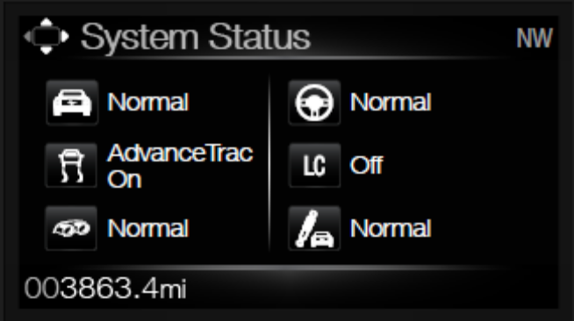
Please refer to program specific graphics library or wallpaper for accurate and latest graphics.

1.3.3.1.2 Indicator Color Coordinates

Reference section COLOR & ILLUMINATION REQUIREMENTS (GRAPHICS).

Audio

None

Switch Control Logic

None.

System Accuracy

Within 100 msec of receiving a message that results in a change of state the cluster will update the output flag to the proper state.

Operation: Performance and Functional

Subsystem Algorithm Flowchart / State Diagram

Figure 2: SVT Status Screen Process Flowchart
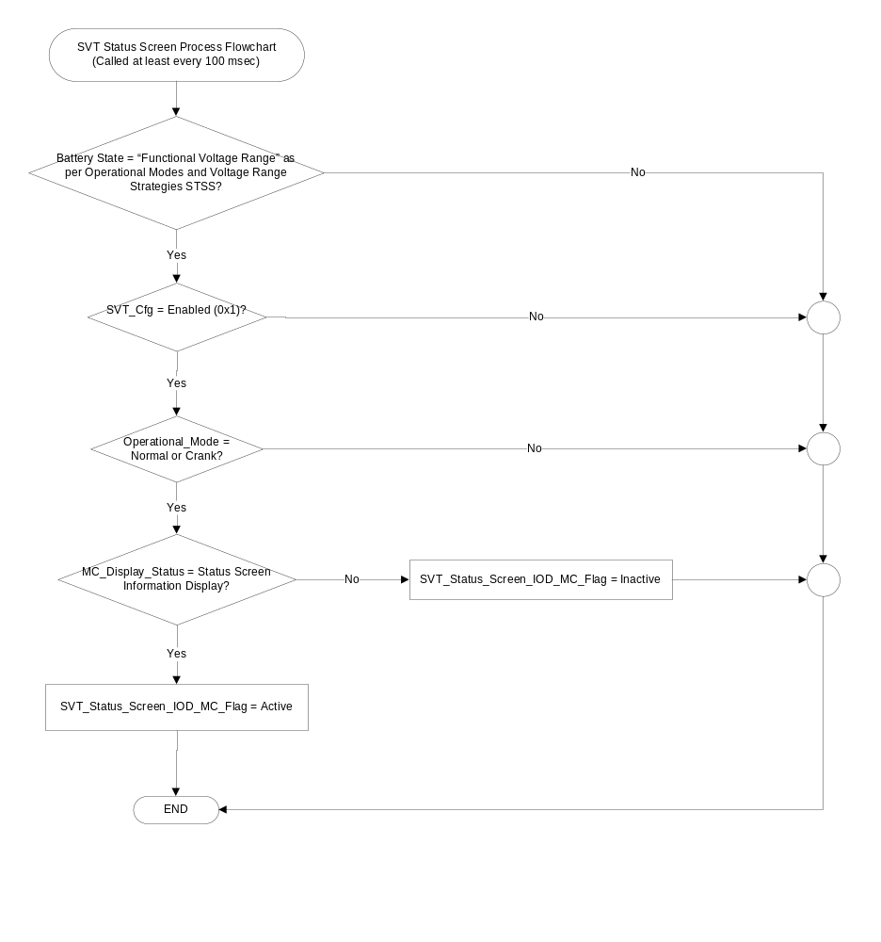

- Matrix for Advancetrac_Status_Screen_MC based on DrvSlipCtlMdeMsg_D_Rq Signal, ESC Off Telltale and Drive mode
Operational_  Mode | Advancetrac_  HB_Ctl_Cfg* | DrvSlipCtlMde  _D_Ind  Signal | ESC_Off  _Telltale | SDM_Status_  Screen_MC | Advancetrac_Status_  Screen_MC  (example graphics)
Normal or Crank | Enabled (0x1) | <> (0x3)  Or  Declared missing as per 1.4.1 | Inactive  (Not Illuminated) | Normal (0x0) | 
 |  |  |  | Sport (0x1) | 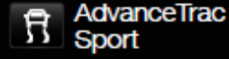
 |  |  |  | Snow_Wet (0x2) | 
 |  |  |  | Track (0x3)  (see note below) | 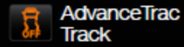
 |  |  |  | Drag (0x4) | 
Normal or Crank | Enabled (0x1) | <> (0x3)  Or  Declared missing as per 1.4.1 | Active  (Illuminated) | Normal (0x0) | 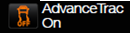
 |  |  |  | Sport (0x1) | 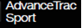
 |  |  |  | Snow_Wet (0x2) | 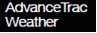
 |  |  |  | Track (0x3) | 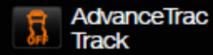
 |  |  |  | Drag (0x4)
Normal or Crank | Enabled (0x1) | 0x3 | X | X | Advancetrac Off
All Other Cases |  |  |  |  | Inactive

Note *: Refer to the “Warning – Traction Control OFF_Traction Control ON_Advancetrac OFF_Advancetrac ON – CGEA1.3” STSS for definition of config bit.

Please refer to the program specific wallpaper for accurate graphics.

Track mode: It is not possible for vehicle to enter “Track” drive mode with AdvanceTrac enabled. Hence this case is captured here mainly to cover bench test scenarios.

- Layout of Status_Screen_IOD_MC

SVT_Status_Screen_IOD_MC (Info Message ID #: I580 – I606)
 SDM_Status_Screen_IOD_MC |  EPAS_Status_Screen_MC
Advancetrac_Status_Screen_MC |  Launch_Control_Status_Screen_MC
 Exhaust_Mode_Status_Screen_MC |  Damper_Mode_Status_Screen_MC

Note: Graphics shown above are for example purposes only. Refer to the program specific wallpaper for

accurate graphics associated with each status.

Operation Description (supports algorithm flowchart /state diagram)

- The SVT Status screen shows the current states of all features it incorporates, as long as the individual features has been configured as Enabled.

- The SVT Status screen is an on-demand information display that can be accessed thru the Track Apps menu via the 5-way MC switch on the steering wheel.

- The warnings contained within the “Warning – Traction Control OFF_Traction Control ON_Advancetrac OFF_Advancetrac ON – CGEA1.3” STSS shall be displayed regardless of the status screen (even when the Status screen is actively displayed).

Function Safety Classification (EMC)

Class B

Memory Storage
Parameter Name | Description | Value at  Battery Connect | Value at  Module Wake-up
SDM_Status_Screen_MC | Refer to the Selectable Drive Modes Control Function – S550 SVT Specific – CGEA1.3 STSS for more information
Damper_Mode_Status_Screen_MC | Refer to the “Dampers Settings Function – S550 SVT Only – CGEA1.3” STSS for more information.
EPAS_Status_Screen_MC | Refer to the “EPAS Selectable Steering Effort Control Function – S550 Specific – CGEA1.3” STSS for more information.
Exhaust_Mode_Status_Screen_MC | Refer to the “Dual Mode Exhaust Control Function – CGEA1.3” STSS for more information.
Launch_Control_Status_Screen_MC | Refer to the “Launch Control Performance Function – S550 Specific - CGEA1.3” STSS for more information.
ESC_Off_Telltale | Refer to the “ESC_Off_Telltale – CGEA1.3” STSS for more info.
Advancetrac_Status_Screen_MC | Status showing current advancetrac mode to be displayed on the status screen | Inactive | Do Not Init
SVT_Status_Screen_IOD_MC_Flag | Output flag to confirm whether the status screen is actively displayed. | Inactive | Inactive
DrvSlipCtlMdeMsg_D_Rq Signal | Input signal received by the cluster | No_Message (0x0) | No_Message (0x0)
Operational_Mode | 4 state indicator for cluster operational mode | Limited | Limited or Normal or Crank

Prove Out

No.

Reconfigurable Telltale

No.

Message Center Msg

Information message IDs I580 thru I606 as defined in the Global Text Message List.
.

Error Handling

None

Diagnostics

Self Test

None

Engineering Test Mode

Not Applicable

Part II Performance

Supported Diagnostic Trouble Codes (DTCs)

DTC | Description | When Logged
None

Reference Specification

IS-0052 OPERATING VOLTAGES - FUNCTIONAL/PERFORMANCE
IS-0069 FUNCTIONAL IMPORTANCE CLASS
IS-0324 WINDSHIELD & OTHER REFLECTIONS
IS-0327 WARNING INDICATOR EVALUATION
IS-0379 NORTH AMERICAN WARNINGS AND INDICATORS STRATEGY

IL-0019 GENERAL ILLUMINATION DIMMING
IL-0021 CRAFTSMANSHIP – DISPLAYS
IL-0022 GENERAL ILLUMINTATION COLOR
IL-0023 CLARITY/LEGIBILITY/READABILITY/VISUAL CONTRAST
IL -0043 OPERATIONAL ENVIRONMENT FUNCTIONALITY
IL -0045 COLOR
IL -0048 ILLUMINATION ACCEPTABILITY

03-0661 PLACEMENT: CONTROL AND DISPLAY LOCATIONS
03-0662 PLACEMENT: LOGICAL GROUPING FUNCTION AND USAGE
03-0664 PLACEMENT: DOWN VISION TO COMPONENTS WITH HIGH VISUAL DEMAND
03-0665 PLACEMENT: EXPECTED LOCATIONS OF CONTROLS AND DISPLAYS VDS
03-0670 INTERIOR VISIBILITY
03-0671 INTERIOR VISIBILITY: REFLECTIONS FROM COMPONENTS & SURFACES
03-0672 INTERIOR VISIBILITY: REFLECTIONS IN DISPLAYS
03-0673 INTERIOR VISIBILITY: VISUAL OBSCURATIONS
03-0674 INTERIOR VISIBILITY: ILLUMINATION CONTROLS / DISPLAYS
03-0675 INTERIOR VISIBILITY: VEILING GLARE
03-0677 INTERIOR VISIBILITY: SUNLIGHT WASHOUT
03-0681 IDENTIFICATION: CHARACTER AND SYMBOL SIZE
03-0682 IDENTIFICATION: LEGIBILITY
03-0685 IDENTIFICATION: SYMBOLS, ABBREV FOR CONTROL
03-0721 LOGIC OF OPERATION: OPERATIONAL STEREOTYPES
03-0722 LOGIC OF OPERATION: INTERPRETATION
03-0723 LOGIC OF OPERATION: USE OF SYSTEMS WITH VISUAL DISPLAYS

Revision History
SPSS Module Revision History

Revision Level | Name | Change Description | Date
1.0 | V. Patel | Initial revision for 2016.75 S550 SVT cluster variant.  Feature owners: Mike Makled, Mike Leese, Zac Nelson (SVT Electrical team) | 12/13/2013
1.1 | V. Patel | Spec updated to display “AdvanceTrac ON” status for state 0x0 of the input CAN signal. (Approved by Jeff Gertley, 10/1/2014)  Section 1.3.5.1, table 1.1: Updated row 4 to include state 0x0 of CAN input.  Section 1.3.5.2: Added a requirement to ensure T/C warnings are only displayed when the status screen is inactive. | 10/2/2014
1.2 | V. Patel | An issue was found where “Traction Control ON” was not displayed on the Status screen. It is because one of the states in the input signal was not processed.  Section 1.3.5.1, table 1.1: Added row to display “Traction Control ON” for state 0x2 of the input signal. | 11/6/2014
1.3 | V. Patel. | The purpose of this update is to expand the AdvanceTrac status to match the Drive mode status. The AdvanceTrac status icons have been changed as well.  (DI CC approval: 2/13/2015, Feature owner: Mike Makled, S550 SVT)  Section 1.2.1, figure 1: Added ESC_Off_TT as an internal input to process the AdvanceTrac status.  Section 1.2.2: Detailed description of the ESC_Off_TT input  Section 1.3.3.1.1.: Updated example HMI graphic of Status screen.  Section 1.3.5.1, table 1.1: Expanded table to process all inputs required to display proper AdvanceTrac status.  Section 1.3.5.2: Updated the requirement that allows the TC/ESC warnings to be displayed regardless of the status screen. Previously, the warnings were displayed only if the Status Screen was not actively displayed.  Section 1.3.5.4: Added ESC_Off_TT as an input for this feature. | 2/17/2015

